Keynote:

1. Regular meeting (16 00 EST, Tuesdays);
2. Github repository created for information sharing.

<https://github.com/OliverAwesome/f_n-MRI->

If anything needs to be changed, send Oliver a push request.

1. Short term goals:
2. Paper reading;
3. Some small projects for the second quarter, 2013, to get everyone started.
4. Long term goals:
5. Methodology development in network study and causal inference.
6. Applications in fMRI and neuroimaging.
7. Define $f_{n}$ (FMI): functional network FMI.

Notes:

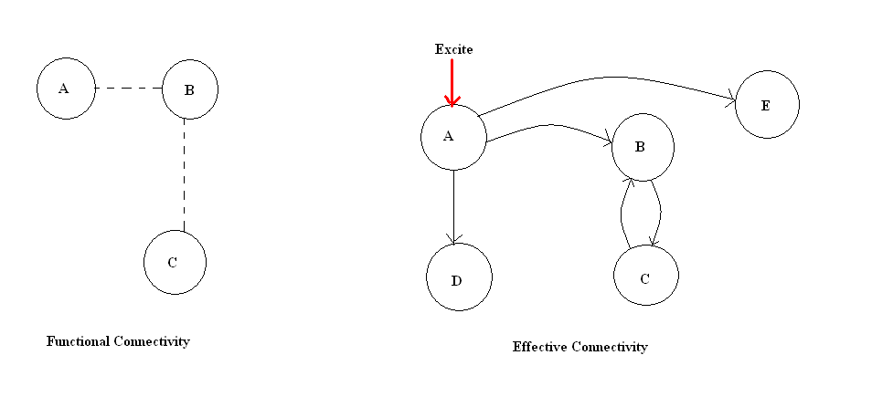

1. Functional Connectivity vs Effective Connectivity: <http://www.fil.ion.ucl.ac.uk/~karl/Functional%20and%20Effective%20Connectivity%20A%20Review.pdf>
2. Transcranial magnetic stimulation (TMS):

<http://en.wikipedia.org/wiki/Transcranial_magnetic_stimulation>

1. Precision matrix ( in functional connectivity):

$Σ^{-1}$ = . Therefore, (A⊥C)/B, as shown in the left picture.

1. Possible network application in brain study.

|  |  |  |
| --- | --- | --- |
| V1 | V2 | Y |
| 3 | 5 | 0 |
| 1.2 | 21 | 1 |
| … | … | … |
| 5 | 9 | 0 |

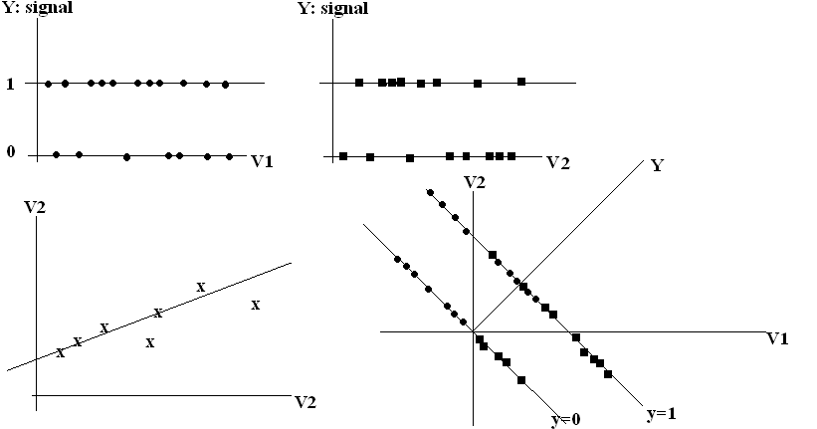

Idea: While the two graphs from the top are not distinguishable for Voxel 1 and Voxel 2, the one in the bottom right corner does tell V1 and V2 apart.

1. Small world: the president is only, say, 6 persons away.  
   hub: Chicago is a airport hub that connects lots of cities, a social butterfly and a hub neuron are with the same spirit in social network and brain, respectively.